MIM V4 — test case TC-02: investigate INC2684835 on vskau1p1277 (a server with metrics but no APM)
Dashboard | MIM V4, Kibana 9.5.3
Objective | Show that an incident on a server that sends metrics but runs no APM services is investigated through its server panels: who owns it, what it is connected to, and how the server, its database and its Windows services are doing
Why this incident | Round 19 picked it for TC-02: a production Windows Server, In Progress, with server metrics, a database and Windows services, and no APM
Result | Pass. Server, Database and Process Health filled; the APM panels stayed empty, as expected. The server's disk is 95.6 % full
How the dashboard is read
The dashboard is read top to bottom, like an investigation:
- Section 1: what is open right now, across all incidents.
- Section 2: what the affected CI is, who owns it, and what it is connected to.
- Section 3: how its applications, services and server are doing.
The controls at the top decide what sections 2 and 3 show. Here the incident's CI is itself a server, so the server panels follow it directly: no Server control is needed.
Test flow
The path followed in this test, with what each step showed.
- Green: the step and its result.
- Amber: a decision.
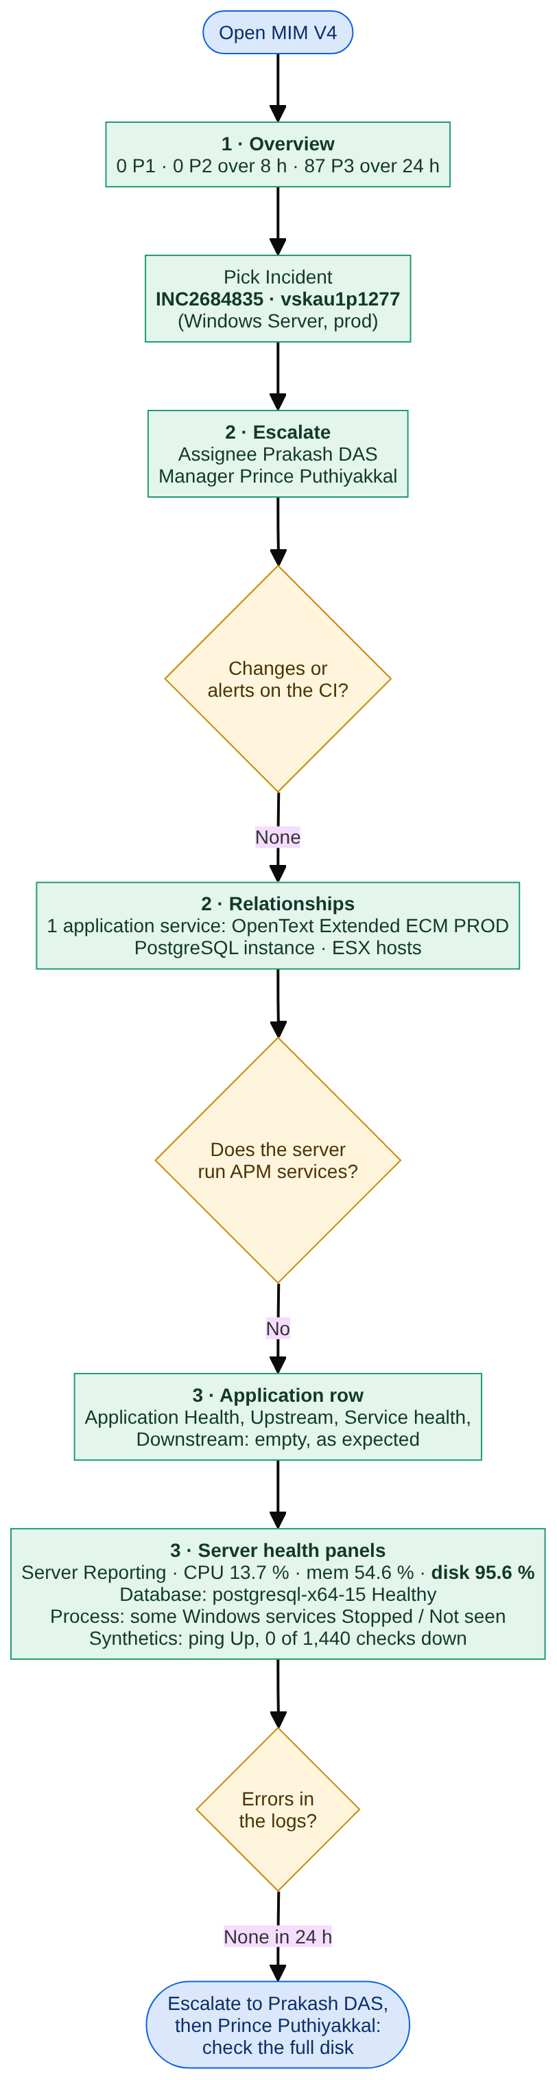
Inputs
Control | Value | Why
Incident | INC2684835 · vskau1p1277 | The incident under test; its affected CI is a Windows Server
CI | (no CI selected) | Not needed: an incident's CI always wins
Server | (no server selected) | Not needed: the incident's CI is already a server
Application / Telemetry | (all applications) | Defaults
Service | (services on this CI) | Default: the APM services on the CI (none here)
Health window | 24 hours | How far back the health panels look

Step 1 — Major Incident Overview
What to show: the starting point for the MIM lead. Section 1 answers "how bad is it across the estate?" and does not change with the incident picked.
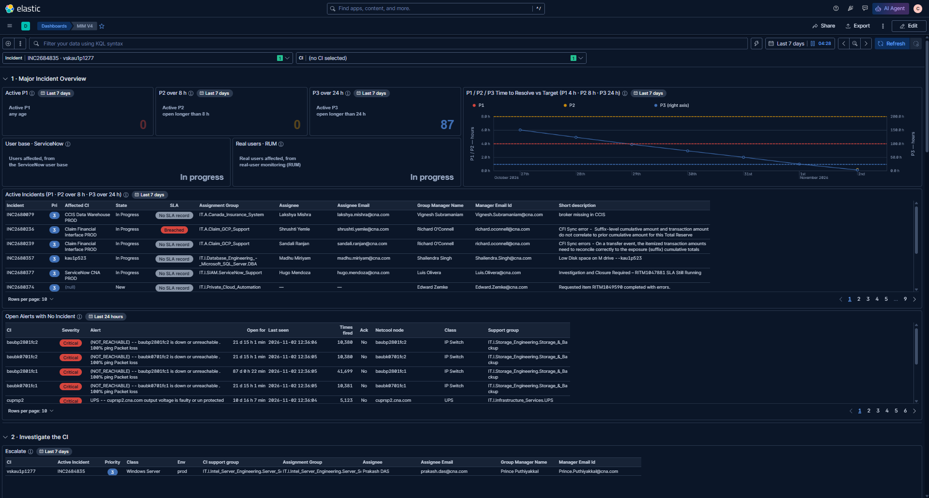
Check | Result
Incident control holds INC2684835 · vskau1p1277 | ✅
Active P1: 0 · P2 over 8 h: 0 · P3 over 24 h: 87 | ✅
Time to Resolve vs Target: P1 / P2 on the left axis, P3 on the right axis, dashed targets | ✅
Active Incidents: SLA column, e.g. INC2680236 Breached, the rest "No SLA record" | ✅
Users impacted: User base · ServiceNow and Real users · RUM, both "In progress" | ✅ placeholder
Open Alerts with No Incident: IP switches unreachable for 21–87 days, a UPS voltage fault | ✅
Notes:
- INC2684835 is not in Active Incidents: it is a P3 opened less than 24 hours earlier, and the table lists P3s only once they pass 24 hours.
- SLA column: only incidents with a ServiceNow SLA record show a status; most show "No SLA record" (the integration gap raised with the ServiceNow team).
- Open Alerts with No Incident: storage switches baubp2801fc1 / fc2 and baubk0701fc1 / fc2 have been unreachable for weeks with no ticket: blind spots worth raising.
Step 2 — Escalation, changes, alerts and relationships
What to show: who owns the server, whether anything changed or alerted on it, and what it is connected to.
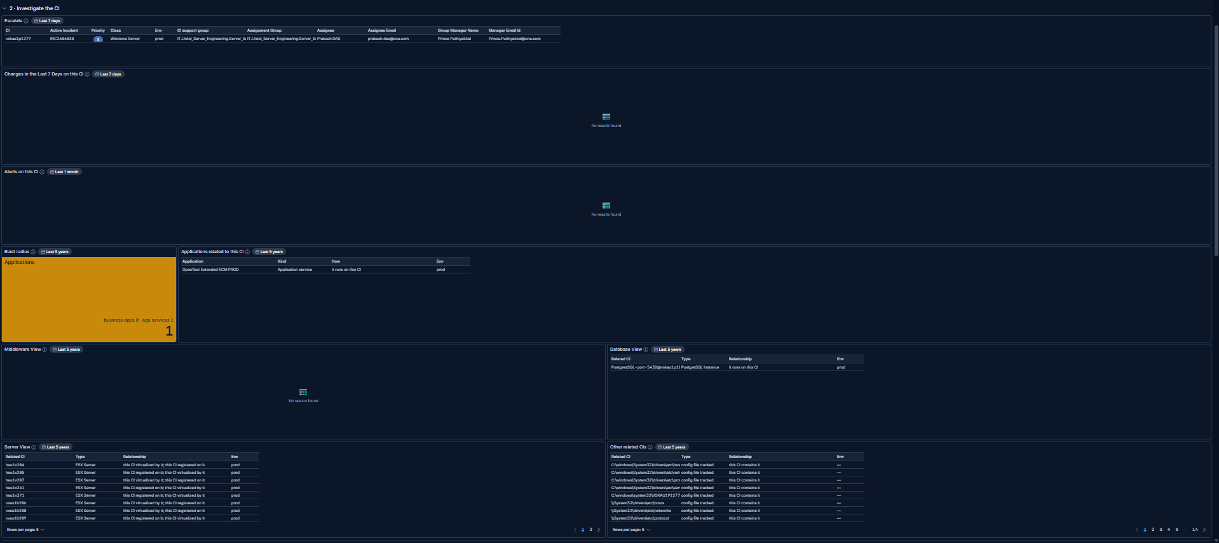
Check | Result
Escalate: vskau1p1277 · INC2684835 · P3 · Windows Server · prod; group IT.I.Intel_Server_Engineering.Server… (cut off in the table), assignee Prakash DAS, manager Prince Puthiyakkal | ✅
Changes in the Last 7 Days: empty | ✅ expected (no changes on this CI)
Alerts on this CI: empty | ✅ expected (no Netcool alerts on this CI)
Blast radius: 1 (business apps 0 · app services 1) | ✅
Applications related to this CI: OpenText Extended ECM PROD (application service, runs on this CI) | ✅
Middleware View: empty | ✅ expected (no middleware CI linked)
Database View: PostgreSQL-port-5432@vskau1p1277 (PostgreSQL Instance, runs on this CI) | ✅
Server View: the ESX hosts it is virtualised by (hau1v204, hau1v205 …; 2 pages) | ✅
Other related CIs: config files tracked on the server (14 pages) | ✅
Notes:
- Escalate names who to call straight from the incident and the CMDB.
- Blast radius 1: if this server fails, OpenText Extended ECM PROD is affected; that is the application to warn.
- Database View shows a PostgreSQL instance on the server, which section 3 checks in Database Health.
Step 3 — Server health, database and Windows services
What to show: section 3 for a server with metrics but no APM services.
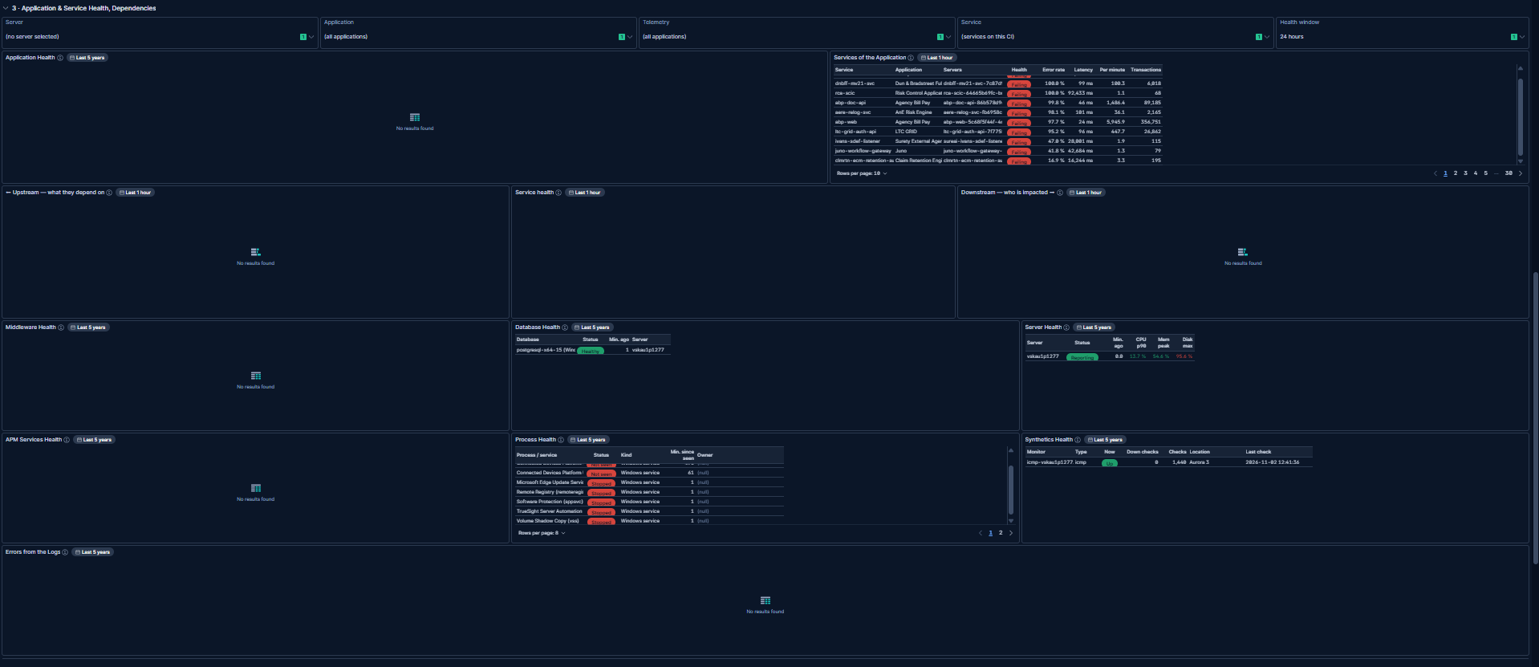
Check | Result
Application Health, Upstream, Service health, Downstream, APM Services Health: empty | ✅ expected (no APM service runs on this server)
Services of the Application: every production service, worst first | ✅ expected (Application on (all applications))
Server Health: vskau1p1277 Reporting, 0 min ago; CPU p90 13.7 %, memory peak 54.6 %, disk max 95.6 % (red) | ✅
Database Health: postgresql-x64-15 (Windows service) Healthy, 1 min ago | ✅
Process Health: Windows services; Connected Devices Platform Not seen; Microsoft Edge Update, Remote Registry, Software Protection, TrueSight Server Automation, Volume Shadow Copy Stopped (2 pages) | ✅
Middleware Health: empty | ✅ expected (no middleware processes)
Synthetics Health: ping monitor icmp-vskau1p1277 Up, 0 down checks out of 1,440, from Aurora 3 | ✅
Errors from the Logs: empty | ✅ no error logs in the 24-hour window
Notes:
- The finding: the disk is 95.6 % full, red from 90 %. That is the first thing for the assignee to check.
- Database Health is found through the PostgreSQL Windows service, matching Database View in step 2.
- Stopped Windows services such as Edge Update, Remote Registry and Volume Shadow Copy usually start only on demand on Windows Server. They are listed so the assignee can rule them out, not as faults.
- Synthetics checks the server from outside: it is reachable.

Outcome
- Pass: a server without APM is investigated through its server panels. Server, Database and Process Health fill from the incident alone; the APM panels stay empty, as expected.
- The server is up and reachable (reporting, ping Up); CPU 13.7 % and memory 54.6 % are normal.
- Its disk is 95.6 % full, the likely cause or a risk to the PostgreSQL database and to OpenText Extended ECM PROD, which runs on it.
- Escalate to: Prakash DAS (assignee), then Prince Puthiyakkal (manager); both are named in Escalate.

